Finlay has shaved his head!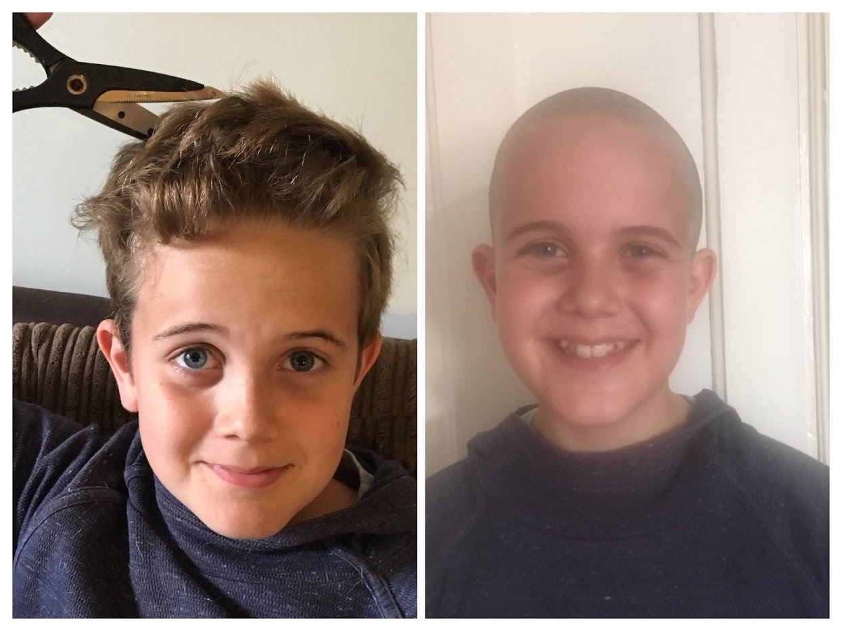

Hello, my name is Finlay George, I am 12 years old. On the 20th July I shaved off all my hair off to raise money for The Spirit of Normandy Trust. The Trust means a lot to me, as I have had a past friendship with a veteran called Norman. He worked as a Royal Marine during the D-Day landings. He sadly passed in 2015. Knowing Norman started my interest in World War II and also inspired me to join the Portsmouth Royal Marine Volunteer Cadet Corps. I have been with the cadets for almost two years now and I really enjoy it. I have always wanted to support veterans and I was lucky enough to meet some D-Day veterans last year. I think it is very important to make sure their stories are always known even when there are no survivors left. I think that the Spirit of Normandy Trust is brilliant and I am really pleased that I have been able to raise nearly £900 to go towards their work. I would like to thank everyone who has donated, it means a lot to me. I have always wanted to help with the charity and everyone has made that possible for me to do so.

