Lady Lucy Houston, the savior of the Spitfire.

Lady Lucy Houston, the savior of the Spitfire.

The Spitfire is an iconic symbol of the RAF in World War Two. It showed its strength and unity in an uncertain time in Britain's history. About 22,000 Spitfires were manufactured during the war. In this essay, I would like to show how Lady Lucy Houston's donations changed the history of Britain for the better without her even knowing by highlighting the Schneider Trophy and the Battle of Britain and the Spitfire's role in saving our country.

The Schneider Trophy and Lady Houston's involvement.
La Coupe d’Aviation Maritime Jacques Schneider or the Schneider Trophy as it was more commonly known as was a Biennial seaplane race running from 1912 until 1931. Many countries took part in the event including Italy, France, the USA and the UK. The winner would be the fastest over a triangular route and would win £1,000- worth £68,000 today. The early 1930s brought worldwide depressions and many countries who would usually race for the trophy were contemplating withdrawing, including Britain. The rules stated that if a country could win the Schneider Trophy three years in a row then that country would permanently keep the trophy and the competition would end. Italy nearly won in 1921, however, the 1919 competition was declared no contest after heavy fog and disqualification of the winning Italy plane. Britain had already won in ‘27 and ‘29 so they needed to win in 1931 to take home the trophy permanently. Nevertheless, in January 1931 the UK government decided to cut funding and banned the race as it was set to take place over the sea between Portsmouth and the Isle of Wight. The Royal Aero Club appealed to the government and offered to raise funds, but nothing changed, this was when Lady Lucy Houston’s donation changed everything.

Lady Lucy was a wealthy benefactor, as well as a devoted patriot and a strong political voice at the time. She had strong beliefs in things like the right for women to vote and showed them very publicly. She used her position, her third husband being a baron, and wealth to set up houses for nurses who served in the First World War and financially supporting other worthy causes like the suffragette movement.
Lady Houston had very different ideas to the government at the time about how the country should have been run. Lady Houston made lots of big statements about her beliefs including sailing around the UK in her large yacht with an electric sign reading “Down with Macdonald the traitor”! She made numerous offers to help support many army and navy causes, but these offers were usually declined.

When she heard about the almost certain withdrawal of the UK’s entry for the Schneider trophy she donated £100,000- Which would be worth about £6,856,90 now to cover all proposed costs for the Royal Aero Club to compete in the race. This was also a political move from Lady Houston as she sent a letter to Ramsay MacDonald saying “Every true Briton would rather sell his last shirt rather than admit England could not afford to defend herself.” Over the next few months, R J Mitchell and his team would work on the winning plane, Supermarine S6, and gain invaluable skills that would later build one of Britain's Most famous planes.

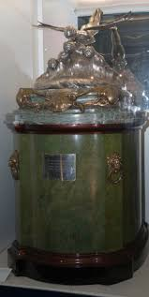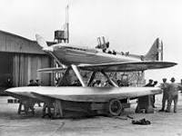
(Left:The Schneider trophy now kept in the science museum, London.Right:The Supermarine S6B before the race.)

Supermarine S.6B
When the planning started for the British entry, there were only 7 months until the Schneider trophy race was scheduled to take place. This then meant that there was not enough time to design and manufacture a new seaplane, however it was enough time to alter the previous years' Supermarine S6 design. The person in charge of adjusting the original plane was R J Mitchell. Reginald Joseph Mitchell was an English aeronautical engineer who was in charge of the Supermarine S.6B. Mitchell aimed to "perfect the design of the racing seaplane" on the Supermarine S.6 when it broke the world air speed record, Mitchell said he had the perfect design. R J Mitchell was also in charge of designing and making a prototype for the Supermarine Spitfire, however, he wasn’t keen on the name saying “Spitfire was just the sort of bloody silly name they would choose.” I wonder if he would like the name now that it is such a well known plane in the UK?

The Supermarine had a Rolls Royce R- type engine and with the help of Lady Lucy’s donation, Rolls Royce was able to increase the output power of the R- type engine. This made a much faster plane. It also was the basis for the iconic thunderous roar of the Spitfire. The Rolls Royce Merlin engine made a loud and unique sound that makes the plane powerful with some amazing mechanical engineering. The engine was used in the Supermarine Spitfire, the Hawker Hurricane, and the Mustang, which made it get the nickname the “Sound of Freedom”.

Battle of Britain
The Battle of Britain was the biggest air campaign in WWII. After the sudden collapse of western Europe in May and June 1940, Hitler turned his focus to Britain. France surrendered on the 22nd of June soon after the extremely successful Dunkirk evacuations of the British expeditionary forces (BEF). They were left to fight the Wehrmacht on their own. In July 1940 Britain was offered peace to end the conflict. However, Churchill and most cabinet members rejected it and said that Britain would keep fighting. The Germans needed to invade England as the fall of Britain would mean victory for the Nazis. Operation Sea Lion was the Nazi’s codename for the invasion of over 150,000 soldiers in the South-East of England. Many were skeptical about how easy it would be to cross the English channel as the Kriegsmarine was inferior to the Royal Navy, it was decided that the best solution would be air superiority over the RAF. On the 1st of August Hitler ordered that “The German air force is to overcome the RAF with all means at its disposal, as soon as possible.” This was the start of the Battle of Britain.

On the 13th of August, the Luftwaffe started their air assault on the RAF. That day was known as Adlertag or Eagle Day after the operation's name (Operation Eagle Attack). On that first day, 1,485 sorties were sent out from Germany. On the 15th of August, there was more intense fighting with 1,790 more sorties flying to Britain. Sorties are attacks coming out from a position of defense. Even though the Luftwaffe was making the offensives, the RAF lost fewer planes than the Luftwaffe every time. This was mostly due to the famous planes of the time the Supermarine Spitfire and the Hawkers Hurricane. The Spitfire being based on the Supermarine S6 and the Hurricane using the same engine.

On the 20th of August, Winston Churchill gave another one of his famous speeches. He addressed the ongoing Battle of Britain saying “Never in the field of human conflict was so much owed to so few.” The ‘Few’ Churchill is talking about are the pilots who risked their lives in the Battle of Britain. This showed how important Churchill thought the battle, the pilots and planes involved were to the safety of Britain. He was implying that we all owe our freedom to the men and women who risked or lost their lives in the battle of Britain. Their achievement was monumental. At the time Hitler had stormed through Europe and when he tried to take the UK, these men and women risked and sometimes gave their lives to stop him in his tracks. Britain stood up to Germany and won! On 12 October 1940 Operation Sea Lion was postponed until 1941 and the Luftwaffe ended their attacks soon after. The RAF managed to take on the Luftwaffe with fewer planes and win, and the Spitfire was a big help. Imagine if the Supermarine S6 and then in turn the Supermarine Spitfire wasn’t developed enough because of lack of funding, would we have a different history to tell?

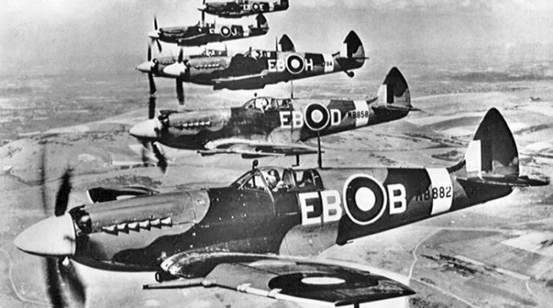
(Picture of Spitfires flying.)

Conclusion
I believe Lady Lucy’s donation was directly linked to the success of many RAF battles, especially the Battle of Britain. The Supermarine S6 was originally only an entry into the Schneider Trophy race- However being the predecessor to the Submarine Spitfire, a truly iconic British fighter aircraft, it is part of British war history. With Lady Lucy Houston's generous donation, R.J. Mitchell was able to continue work on his plane. Even though Lady Houston didn’t live to see the Spitfire, her donation meant that Mitchell and his team had the experience in producing aircraft in a short amount of time. This prepared them for the war ahead. Without her help, the project would have failed. I think even Lady Lucy Houston herself would be shocked, and extremely happy, that her donation could have made such a difference to her country.

Bibliography
https://web.archive.org/web/20061013075335/http://www.rjmitchell-spitfire.co.uk/schneidertrophy/1931.asp?sectionID=2
https://www.nigelblackwell.com/2013/04/lady-lucy-houston-defeat-luftwaffe/
https://en.wikipedia.org/wiki/Schneider_Trophy
https://www.hydroretro.net/race1919
https://www.airspacemag.com/history-of-flight/the-schneider-trophy-22580584/
https://winstonchurchill.org/the-life-of-churchill/war-leader/1940-1942/battle-of-britain/
https://www.military-history.org/articles/the-battle-of-britain-a-brief-guide.htm
https://nzhistory.govt.nz/war/battle-of-britain/invasion-threat
https://en.wikipedia.org/wiki/R._J._Mitchell

For photographs
https://www.historyhit.com/facts-about-the-supermarine-spitfire/
https://en.wikipedia.org/wiki/Supermarine_S.6B
https://en.wikipedia.org/wiki/Schneider_Trophy

