The British Merchant Navy
What contribution did the British Merchant Navy give to the Allies in World
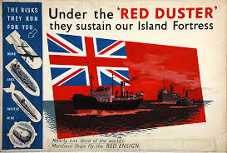
War 2?
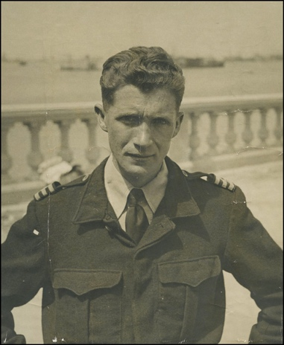

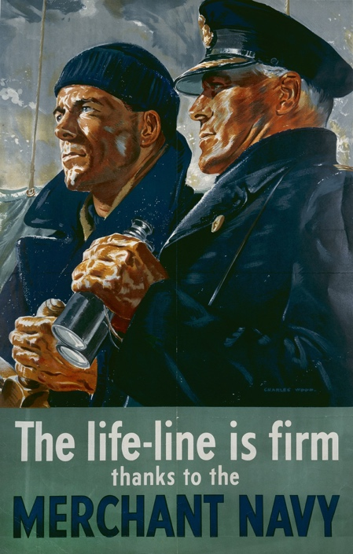

By William Joseph James Huckle
Year 5
St George’s International School
Luxembourg
Contents
Page 3: Introduction
Page 3: Who were the Merchant Navy?
Page 4: What did the Merchant Navy do and what the dangers of being a Merchant Seafarer?
Page 5: My Connection with the Merchant Navy.
Page 6: The Battle of the Atlantic
Page 7: Conclusion
Page 8: Bibliography
Introduction

In this essay, I will be discussing the role of the British Merchant Navy during World War 2. In doing this, I will be exploring who they were, what they did and why they were such a valuable asset to the success of the Allies in the Second World War.

Who were the Merchant Navy?

In order to investigate the contribution of the Merchant Navy to the British wartime efforts, we must fully understand their origins and who they actually were.

The British Merchant Navy was a branch of the Royal Navy (or British Navy), formed in 1835. Their original individual purpose was to supply Britain with food and raw materials from overseas. It was the British Government that launched this initiative. From 1835 – 1918 it was called the Merchant Marines, but then, in 1919, King George V named them with the iconic name of the Merchant Navy.

During the Second World War, the Master of the Merchant Navy was King George VI. This meant that he had to authorise any shipment and had overall responsibility of the well-being of the fleet and seamen.

In 1939, half the food needed by the British population was imported from abroad and two-thirds of the raw materials used by British industry also came from overseas. It was the role of the Merchant Navy to ensure that these essential supplies were maintained. At the beginning of the war, 33% of the world shipping tonnage was shipped by the Merchant Navy. As well as that, the British Merchant Navy was the largest and most inscripted Merchant service in the world, with 185,000 seamen. Every person within the Merchant Navy was a civilian or volunteer.

Life was extremely tough in the Merchant Navy. Food was scarce, the rules were harsh, U-boats were lurking underneath the surface of the water and you were 4000 miles from your family. The weather did not help either, storms would be raging most days and the temperature could drop to -20°C.

What did the Merchant Navy do and what the dangers of being a Merchant Seafarer?

Up until 1939, the British Merchant Navy shipped 55 million tons of food and raw materials every year.

Between 1940 and 1943 it was the lifeblood that kept Britain and the Allies from losing the war. Working with the American program, Lend Lease, it not only gave the civilians in Britain food but also those Allied troops out on the battlefields of Belgium and France.

They did not only ship supplies from America, but New Zealand and Australia as well. These countries were easier to ship from because they were out of the Nazi’s reach. Even though the vessels that shipped from these countries eventually entered the Atlantic -within Germany’s reach- these ships could just slip behind the German vessels.

The only problem the Merchant Navy had were the U-boats. No matter where you ship from, they will always be in your way. They were armed with 3 torpedo shooters and a 10-inch gun for when they surfaced. When together they were the Wolfpack. Another German machine to be scared of was the Focke-Wulf FW 200 Kondor. These bomber/reconnaissance planes were based in Bordeaux, France. They would sweep across the Atlantic and bomb any Merchantmen (Merchant ships) that were straggling from their convoy. If an entirely new convoy they would report it to the nearest U-boat/s.

It was not only Germany that was dangerous, the weather was one of the Merchant Navy’s worst enemies. If a storm churned up, a Merchantman could lose half its tonnage and up to a sixth of its seamen overboard since men and supplies were not very secure. Even the ship was a great danger. You would breathe in diesel fumes for every day up to six weeks. The floors were wet and slippery and metal bars were hanging low. The chance of concussion was extremely high.

My Connection with the Merchant Navy.

My great-grandfather was a Chief Electrician serving in the Merchant Navy during the Second World War. This chapter is here to tell you all about him and his life in the Merchant Navy. Though I am sad to inform you that he died thirty-two years ago.

Joseph Clarke was born on the 11th January, 1913 in New South Wales, Australia. When he was six months old his family moved to 9, St. Aiden’s Avenue in Sunderland, England.

When the war broke out in 1939, he applied for the British Merchant Navy. On the 26th March, 1941, he set out on his first ever vessel, the SS Otaio. They were to collect raw materials from New South Wales in Australia. When his family had moved to England, his cousins had stayed in Australia and he went to see them. Finally, they arrived back in London on 31st July, 1941.

Two months later, on 26th September, 1941, he joined the crew of the SS Opawa. They were headed to New Zealand. But sadly, on the return voyage, 400 miles north from Bermuda, on 6th February, 1942 the ship was sunk by the U-Boat U-106. 56 dead, only 15 survivors. But lucky enough for me and my family, my great-grandfather was saved by the Dutch steam merchant Hercules.

Four months later, on 3rd June, 1942, he married Florence Anderson at the age of 31. After the war, they would go on to have two children. In 1946, David Clarke was born, and in 1949, my grandmother, Delia Clarke was born. But then, in 1946, at the age of only 10, David died.

Now came his final ship. He worked on the SS Hororata for three years and two months. His first voyage was on 11th April, 1942. Sadly, in the middle of the Atlantic Ocean, the ship was hit by U-boat U-103. Luckily the ship was only damaged and managed to get back to Plymouth safely.

Being hit twice by a U-boat torpedo was not the only adventure he had, he has also got a commendation from Winston Churchill himself. The reason he was rewarded this was because: a ship full of munitions set on fire in the London Docks. If it blew up, it would destroy the Allies main docks. My great-grandfather and others volunteered to row out to the boat and steer it away from the docks. He risked his life for the Allies.

But sadly, all great men and women must come to an end. My great-grandfather died from Bronchial Baranomia on New Year’s Eve 1987. Since then, my family has never hugely enjoyed New Year’s Eve. I would like to say
a great thanks to my great-grandfather as he inspired me to research the Merchant Navy which led me to writing this essay.

The Battle of the Atlantic.

The Battle of the Atlantic was the longest battle in history, 5 years, 8 months and 5 days. It was the fight between Britain (and later, America) and Germany.
Germany’s aim was to cut of British supply lines from across the Atlantic.

This devastating battle began on 3rd September, 1939, the day the war was declared. German U-Boats would patrol the ocean for any British Merchantmen. Their low silhouette meant they were hard to spot; however, their victims would tower in dark void of the sky. During the early months of the war, U-Boats would fight individually, until Grand Admiral Doenitz thought up the idea of a wolfpack. This was a very effective tactic and in using this, from September 1939 to the end of 1940 U-boats sunk 4,800,000 tons of Merchant shipping and more than 700 vessels.

‘I was even more anxious about this battle than I had been about the glorious fight called the Battle of Britain,’ wrote Churchill in his acclaimed history, The Second World War.

The war at sea was looking doubtful for the Allies, but then, Britain hit gold. Hitler refused Doenitz’ request for more U-Boats which left him with only less than a hundred in the Atlantic. Moreover, since the Battle of Britain had finished, the RAF could send planes to assist British Merchantmen and British Naval Commanders came up with the idea of a convoy. Since America had joined the war, they could lend Britain destroyer ships. The convoy would work like this: approximately 40 ships would be escorted by four American destroyers and two bomber planes.

This work effort paid off and in 1941, the tonnage sunk dropped by over 900,000 tons. Britain were coming back.

But just as Britain thought they would win, Hitler made Doenitz, Supreme Commander of the German Navy, meaning Doenitz could have as many U-boats in the Atlantic as he wanted. Then escort number of planes increased to four planes per convoy and in 1942 Britain lost 2,200,000 tons of Merchant shipping.

Luckily enough for Britain, Churchill came up with a plan to get through the German U-boats. The U-boats would be spread out in a line of one hundred miles. There would be five miles between each U-boat. Churchill would send two destroyers up to then line, but then they would turn back; this forced the U-boats to the surface where the bomber planes would sink the U-boats.

Eventually in March, 1943 the Allies won this battle, but U-boats would still roam the seas the until Germany’s surrender in May, 1945. Extended the battle for another two years.

Conclusion.

My thoughts on the Merchant Navy are mainly one thing: our saviours. They would risk their own lives every day for months. They would give Britain food whilst fighting the treachery that was the Nazis. They shipped over a hundred million tons of food, raw materials and oil in only six years. They deserve just as much credit of winning the war as the Royal Navy, the British Army and the Royal Air Force does. They travelled tens of thousands of miles from their families, just so we could live the lives we live today.

Yes, D-Day helped, cracking the Enigma helped, but the Merchant Navy was the key to Britain’s success.

Bibliography
Websites
http://www.theprow.org.nz/framework/main.php?url=/events/nelson-ships-wwi/
https://www.marineinsight.com/life-at-sea
http://ussslater.org/history/dehistory/history_atlanticbattle.html
http://merchantships.tripod.com/

Articles
U-Boat Wolfpacks: Hunters of the Atlantic. Hitler’s Third Reich.
The Deadly Wolfpack. Story of World War II.

Interviewees
Delia Hoad née Clarke (my grandmother)
Andrew Hoad (my grandfather)

Film
World at War, 1973.

