Contents
Page 1: Contents

Page 2: Introduction

Pages 3&4, Chapter One: The Home Fleet and Scapa Flow

Pages 5&6, Chapter Two: The sinking of HMS Royal Oak

Pages7&8, Chapter Three: The Churchill Barriers

Pages 9&10, Chapter Four: Air Raids

Pages 11&12, Chapter Five: Defences and Airfields

Pages 13&14, Chapter Six: Convoys

Page 15: Conclusion

Page 16: Bibliography

Pages 17-20: Appendices

Introduction
Orkney is an archipelago off the north coast of Scotland consisting of 70 islands in total, only 20 of which are permanently inhabited. Its 70 islands had a population of approximately 20,000 before the war, this rose to 60,000 during the war.
I intend to show how vital Orkney was to the British and Allied war effort by looking at the importance of Scapa Flow and the Home Fleet and how the sinking of the HMS Royal Oak changed the course of the war. To show how significant Orkney was I will discuss Germany’s attacks and Orkney’s defences. I will also prove how important the North Atlantic convoys were to the British and Allied War Effort and how these were protected by the Home Fleet.

Chapter One
The Home Fleet and Scapa Flow
Orkney housed the Home Fleet during both World Wars in a natural harbour called Scapa Flow. Scapa Flow is surrounded by the Orkney Islands and was used by the Vikings and its modern name is taken from its Norse name of Skalpaflói. Yet it wasn’t until Napoleonic times that the Admiralty took interest in the harbour and started to use it to station Royal Navy ships. The Home Fleet which Scapa Flow housed is a fleet of Royal Navy ships designated to protect the home waters. The home waters are the waters in and around Britain. In 1939 there was a total of 48 ships and 21 submarines in Scapa Flow as part of the Home Fleet. Scapa Flow was considered impregnable by the British after its use during the Great War, it was also sheltered from storms and was large enough to hold the entire Home Fleet at anchor, this was why it was considered to be such an important Royal Navy base. In addition to this there were seven different entrances to the North Atlantic (See Appendix One) giving the Home Fleet easy access to the waters it was expected to protect. Scapa Flow was protected by extensive defences left over from the previous war which were eventually added to. There were many blockships, booms and a surprising 6.52 miles of anti-submarine nets with the addition of 6.1 miles of anti-torpedo nets. Blockships were ships that were deliberately sunk to narrow the channels used to access some of the entrances and booms were retractable floating barriers that were used to bar the passage of ships. This natural harbour, Scapa Flow, made Orkney vital as it controlled access to the North Atlantic making it difficult for the Kriegsmarine (German Navy) to access the North Atlantic thus protecting the crucial shipping routes that proved so critical to the outcome of the war.

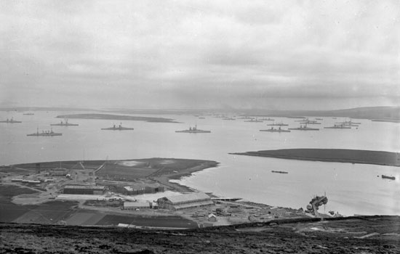
Home Fleet at anchor in Scapa Flow
Chapter Two
The Sinking of HMS Royal Oak
Yet soon the British comfort in Scapa Flow turned into complacency, something which the head of U-Boats (See Appendix Two) Karl Dönitz took advantage of. He began to plan an attack on Scapa Flow, an attack which he believed “would be a great coup” and would lead to “shattering British morale”. He planned to send a U-Boat into Scapa Flow and sink a battleship. He eventually discovered after a lot of investigation and evidence gathering that out of the 7 available entrances a “U-boat could only enter the Flow from the east, where there was a tight route between the blockships in Kirk Sound.”. Dönitz was confident that it would be possible to penetrate Scapa Flow at this entrance, at night, on the surface, but only at slack water. He said that “The main difficulties will be navigational.” showing his confidence in his plan and U-Boat commanders, specifically Günther Prien who was the Captain of U-Boat U-47. On October 13th 1939 U-47 made its way to Orkney and waited outside Scapa Flow. It crept through Kirk Sound (See Appendix Three) and into Scapa Flow and began searching for a target. It eventually came upon the HMS Royal Oak anchored next to HMS Pegasus in Kirkwall Bay. Yet because of it’s positioning the HMS Royal Oak had to be targeted first. In all the U-47 fired 6 torpedoes with four hitting their target causing devastation and destruction. The HMS Royal Oak sank within 10 minutes sadly taking 833 of her crew with her. On board the HMS Royal Oak were 161 boy sailors aged 14-18, 126 of which died making this the largest loss of boy sailors in the history of the Royal Navy. Initially no one knew why the HMS Royal Oak had sunk until some divers at the wreck discovered the propeller of one of Prien’s torpedoes. This exposed that the impregnable Scapa Flow was maybe not as impregnable as it was first deemed to be, showing everyone involved that the defences of Scapa Flow needed upgraded. All of this led to Winston Churchill himself visiting the islands, thus showing the level of importance the British Government placed on Orkney and it’s essential part in the Defence of the nation and to the allied war effort. Winston Churchill himself said that “It is still a matter of conjecture how the U-Boat penetrated the defences of the harbour. When we consider that during the whole course of the last war this anchorage was found to be immune from such attacks on account of the obstacles imposed by the currents and net barges, the entry by a U-Boat must be considered as a remarkable exploit of professional skill and daring.”. The country was in shock as Scapa Flow was believed to have been impregnable to attack.
To protect the Home Fleet from further attacks Churchill ordered the building of concrete causeways across the Eastern entrances. This would ensure that a disaster like the Royal Oak could never be repeated.
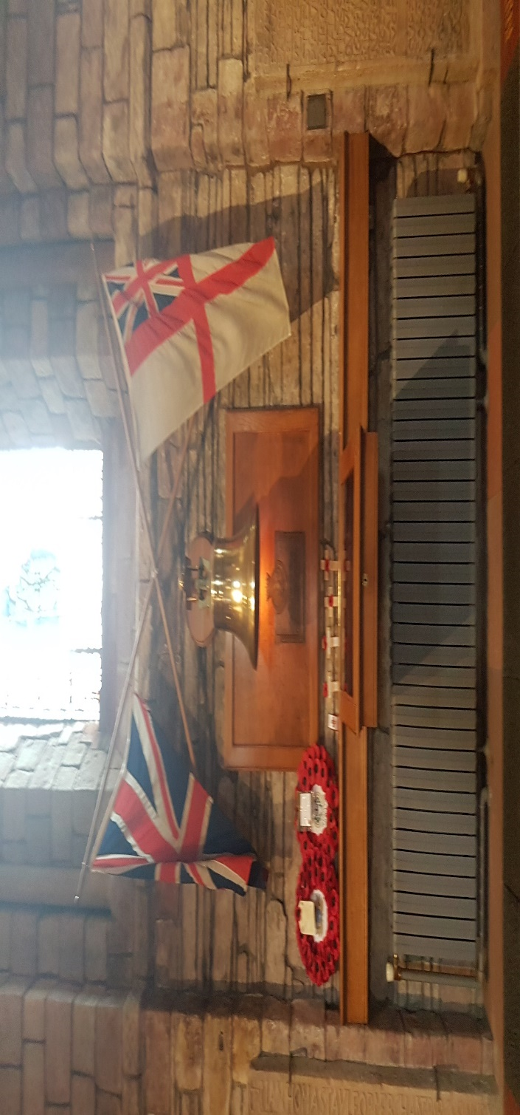
Following this tragedy, the U-47 snuck back out the same way it had come in, radioing Germany sending news of the successful completion of their mission. The U-47, Gunter Prien and his crew arrived back in Germany and received a hero’s welcome. Prien and the crew were flown to Berlin to meet with Hitler and his Propaganda Minister, Joseph Goebbels, and were presented with the Iron Cross 2nd class. Prien was presented with the Knights Cross of the Iron Cross, the highest medal possible in the German Armed Forces and he was the first submarine commander to receive this accolade in World War 2. The Nazis used this as a means of propaganda against the Royal Navy. They had entered the impenetrable Scapa Flow, sunk a Royal Navy ship and had sneaked back out again, all without being caught. The success of this attack was so significant that Hitler lifted the previous restrictions on U-Boat operations. The U-Boats were now free to attack all enemy ships including liners travelling in convoys. Without the sinking of the HMS Royal Oak, Hitler may not have altered the policies surrounding the use of the U-Boats. Without this change in policy the attacks on the North Atlantic Convoys may never have happened which could have led to the Home Fleet being based elsewhere in the UK. This would have led directly to a different involvement for Orkney in the war.

Right: The bell of the HMS Royal Oak available to view in St Magnus’ Cathedral, Kirkwall

Chapter Three
The Churchill Barriers
The Churchill Barriers are a series of four concrete causeways stretching across the Eastern side of Scapa Flow where the U-47 entered Scapa Flow and sunk the HMS Royal Oak. The building of the barriers were an enormous undertaking and was going to require a tremendous amount of manpower, resources, time and money, all of which were in short supply due to the ongoing war. The initial estimate for building the barriers was £2,000,000 (about £67,000,000 in today’s money) compared to an average annual income of £129.00. Work commenced on the barriers in May 1940 and they were completed in September 1944. Work was initially carried out by British and Irish workers. However, workers soon became scarce as the men were needed on the front line. The Government needed another solution as the work was too vital to stop. They decided to bring in Italian prisoners of war captured in North Africa to build the barriers. Over 1000 Italians were individually selected for their skills and abilities and were transported via ship to Orkney.
There were 2 camps for these prisoners to live in, Camp 34 and Camp 60. Camp 60 was located on Lamb Holm (See Appendix Three). At this time Lamb Holm was devoid of life and did not even have a running water supply. The camp was constructed of 13 Nissen Huts each with a capacity of 50 men each yet it only held 550 prisoners out of the possible 650 it could at capacity. Running water for the camp was carried over in a pipe from the mainland that was placed on top of a submarine net.
At the labour forces’ peak there were 1,720 workers, 1,200 of which were Italian. But before the Italians left the Orkney Islands, they had built a chapel (See Appendix Four) out of a spare Nissen hut that had been used for schooling and prayers and turned it into the Italian Chapel. They used concrete donated from the building site and metal from the blockships.
The fact that the Government was willing to bring in over 1000 Prisoners of War to Orkney on a perilous sea journey just further accentuates Orkney’s significance. Furthermore, over four years was spent working on these barriers being used to protect the harbour of Scapa Flow, this highlights the importance placed on this harbour. The building of these barriers and the amount of money, time, resources and manpower that the government were willing to use on these is just an indication of how important Orkney was regarded to be in the overall Allied and British war efforts.
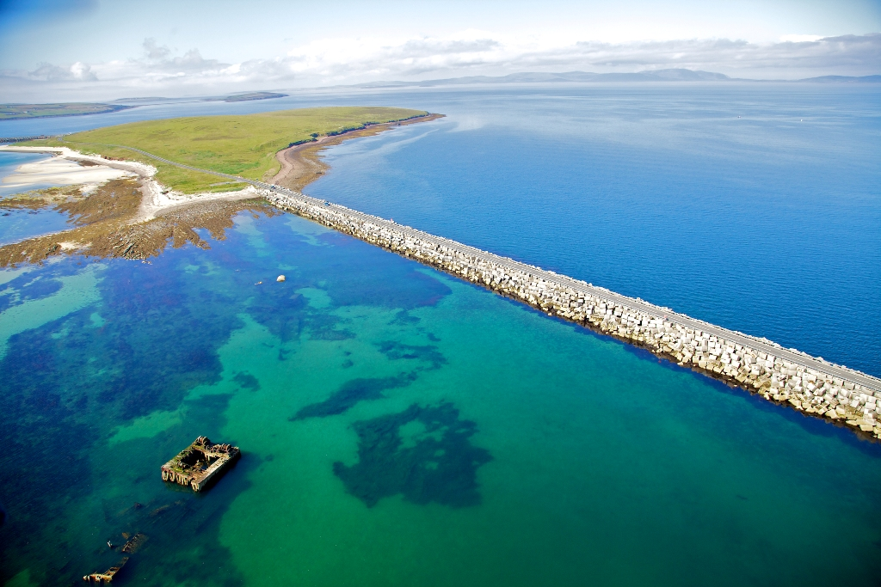

Right: The modern day Churchill Barriers

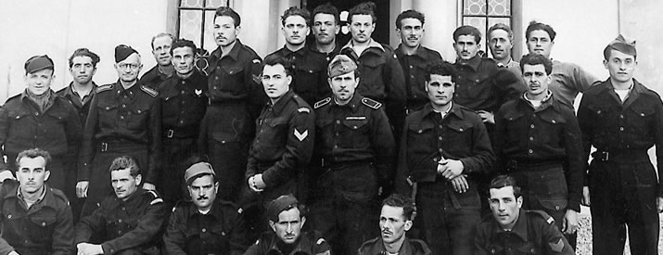

Left: Some members of Camp 60

Chapter Four
Air Raids
Not only did Orkney house the Home Fleet, prisoners of war, evacuees and refugees it was also considered a front line and suffered many air raids. Some of the first air raids happened here along with the first bomb to fall on British soil, this bomb fell on a potato farm on the Orkney island of Hoy. The first air raid on Orkney was on 17th October 1939 when two waves of Junkers 88s planes attacked Scapa Flow in search of the Home Fleet, which after the sinking of the HMS Royal Oak on the 14th of October 1939, had left Scapa Flow for safety reasons. Two of the planes were shot down. The first civilian to die on British soil was killed in an air raid on March 16th 1940, which is said to have been the best organised attack by the Luftwaffe during the course of the Second World War. The civilian that died was James Isbister aged 27. During the period of March to April 1940 there were several air raids on Scapa Flow. Heavy air raids took place on the 8th and 10th of April 1940 these air raids had two objectives, the 8th was used as a diversion to keep the Home Fleet and the planes protecting them away from the Germans invasion of Denmark and the 10th was used to cover the invasion of Norway and an attempt to put the naval base out of operation to give the Kriegsmarine access to the North Sea. Towards the end of April, the air raids began to stop however there were still small invasions by single planes or small groups but this “rarely resulted in much more than local damage and a test of the defenders’ readiness.”.
All of this shows that the Germans thought that Scapa Flow and Orkney were important enough to spend time and resources on. By using air raids as diversion tactics the Germans tied up the Home Fleet and planes meaning they could invade Denmark and Norway without disruption from Britain. This demonstrates how important Germany perceived The Home Fleet and Airfields on Orkney to be to the British and Allied war efforts. The fact that the Germans tried to put the naval base out of action shows how strategically important Orkney was. Whoever controlled Orkney could control access to the North Sea and North Atlantic, making Orkney strategically vital to both Britain, the Allies and the Nazis.
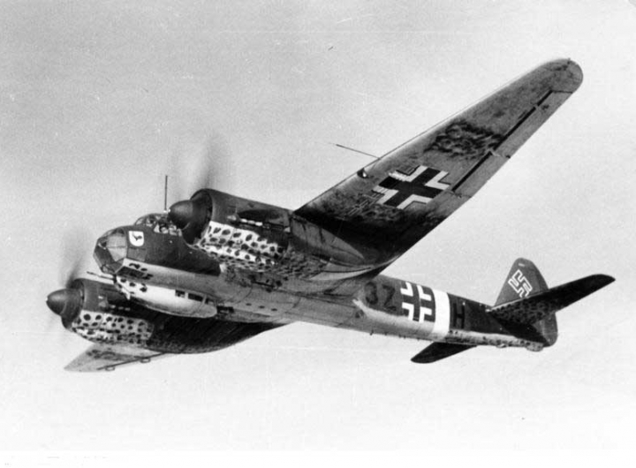
A Junker 88 plane
Chapter Five
Defences and Airfields
Orkney was made Britain’s first protected area of the Second World War, meaning anyone wishing to enter or leave the islands had to have a pass to do so, this was one of the many layers of defences Orkney used.
Orkney also had many physical defences. In total Orkney had six separate airfields, not including the Scapa Beach seaplane station. Five dummy aerodromes were also constructed in an effort to confuse the Germans. The airfields held many planes, pilots and staff. There were many different types of planes flown from them some were the Spitfire, Seafire, Swordfish, Barracuda, Martlet, Walrus, Avengers and Roc. There was a mixture of fighters, bombers, torpedo bombers, sea planes and carrier-based aircraft offering a range of different defences to protect the Home Fleet, Scapa Flow and Orkney. Not only were the planes used for defensive reasons but also used on the offensive against the German pocket battleships such as the Tirpitz, Bismark and Scharnhorst. The defences had been recently updated after the air raids of 1939 and 1940. In 1937 there had been reconstruction work at Lyness to build a Boom Defence Depot. There were also many searchlights, coastal batteries and booms that were being constructed or reused from the previous world war. The Churchill Barriers were under construction to stop U-Boats and ships entering Scapa Flow.
All of the above highlights how vital Orkney was deemed to be to the British and Allied War Efforts. The remarkable number of airfields and defences for such a small group of islands shows the importance that the Ministry of Defence placed on Orkney. Without this multi layered defence Orkney could have been far more vulnerable to attacks than they were during the war, resulting in the loss of the Home Fleet and possibly the war.

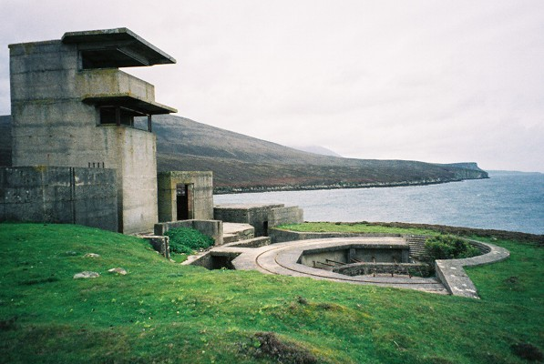

Left: A coastal battery on Hoy

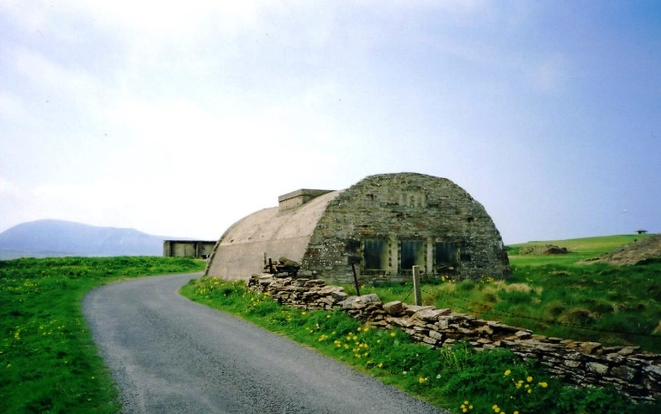

Right: An engine room used for Links Battery

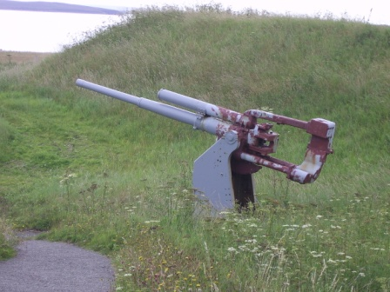

Left: AA Gun at the Lyness museum

Chapter Six
The Convoys
The convoys were groups of ships from America and Canada delivering food and essential war resources to Britain and her Allies while being escorted by ships from Scapa Flow. These resources were vital to the British and Allied war effort. The Home Fleet was the main group of ships used to protect these integral convoys, everything from battleships to fishing boats were used to protect these ships on their vital journeys.
Throughout the Second World War 450 convoys were ran. These convoys were launched by America after having created the Lend Lease agreement, this agreement meant that America could remain neutral but still send supplies to any country.
The convoys destined for Russia were known as the Arctic Convoys. These Arctic convoys delivered at least 7,000 airplanes, 5,000 tanks, trucks, tyres, fuel, food, medicine, clothes, metal and other raw materials to Russia. Without these raw materials it is very likely that Russia would have lost the war against Nazi Germany. This would have resulted in the freeing up of millions of German soldiers, tanks and planes that could easily have been used to invade Britain. At the same time Britain was starving and relied on these convoys to continue their war effort. Britain required to import 1 million tonnes of goods per week just to survive. These made Orkney vital to the British and Allied war effort as the convoys that were fundamental to the survival of Britain and Russia were protected by the ships and planes from the Home Fleet, in Scapa Flow. Not only did Orkney protect the convoys it also tried to elminate the huge dangers these convoys faced. Hitler had released the U-Boats after the sinking of the HMS Royal Oak and they were now free to hunt these convoys and sink any ships sailing in them. The German navy also had several famous Battleships like the Bismarck, Tirpitz and Scharnhorst. These battleships all operated in the North Atlantic with the aim of sinking the ships in the convoys.
Planes and ships from the Home Fleet were central in the destruction of these three ships and in the hunting out and sinking of the U-Boats that were causing devastation to the convoys. In September 1939 alone 50 ships carrying over 200,000 tonnes of vital supplies were sunk by U-boats.
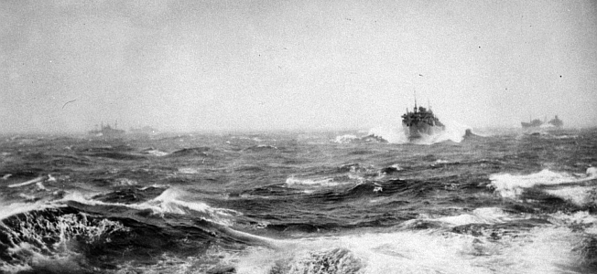
Without the protection offered by the Home Fleet the losses sustained by these convoys would have been unsustainable. More ships were being sunk than could be built. This would have resulted in the convoys being stopped all together, having massive implications for the outcome of the war. Russia would have lost their war with Germany freeing up her armed forces to invade Britain. Britain would either have surrendered or been invaded by the Nazis. This would mean that Britain would have been unavailable for the Americans to use as a base and that the D-Day landings would not have been possible resulting in Hitler winning the war.
The Russian convoys travelling to Murmansk

Conclusion
I have demonstrated how vital Orkney was in the war effort by looking at the role of the Home Fleet and Scapa Flow. Not only do I think that Orkney was vital, Winston Churchill and the Germans also thought this. Winston Churchill ordered the building of all of the defences, highlighting the importance he placed upon it. The Germans launched heavy offensives and highly decorated their soldiers following the successful sinking of the HMS Royal Oak. The sinking of this ship has far reaching consequences, changing the way the Germans fought during the war. If we consider the outcome of the destruction of the North Atlantic Convoys, it would have been catastrophic to the British and Allied war effort and would have led to Germany’s success. It is surprising how such a small group of islands could have altered the course of world history so dramatically.

Bibliography
https://www.scotlandinfo.eu/orkney/
https://www.marineinsight.com/maritime-history/8-facts-about-the-scapa-flow/
https://www.historytoday.com/richard-cavendish/german-battle-fleet-scuttled-scapa-flow
https://hoyorkney.com/portfolio/the-battle-for-orkney-and-the-air-assault-on-scapa-flow/
https://www.warhistoryonline.com/world-war-ii/5-of-the-largest-amphibious-invasions-in-modern-history-m.html
http://www.orkney.gov.uk/Service-Directory/T/airfields.htm
https://orkneyuncovered.co.uk/orkneys-wartime-airfields/
http://www.crashsiteorkney.com/orkney-airfields-
http://www.crashsiteorkney.com/orkney-coastal-batteries
https://hoyorkney.com/portfolio/the-arctic-convoys/
https://www.iwm.org.uk/history/the-convoys-that-helped-save-britain-during-the-second-world-war
https://www.bbc.co.uk/history/ww2peopleswar/stories/06/a6281606.shtml
https://www.bbc.co.uk/history/ww2peopleswar/stories/51/a2248751.shtml
https://www.rbth.com/longreads/arctic_convoys/
https://history.state.gov/milestones/1937-1945/lend-lease
https://www.bbc.co.uk/history/ww2peopleswar/stories/62/a4517462.shtml
https://uboat.net/
The Sinking Of HMS Royal Oak by Dilip Sarkar
Orkney’s Italian Chapel by Philip Paris
The North Atlantic Front by James Miller
Jude Callister, Orkney Museum

