The Southampton dispersal factories of 1940-1945 and their impact on local citizens

By Elizabeth Lotery, Year 10, King Edward VI School, Southampton

GCSE Local History Prize: for individual work on a Local History theme.

The Southampton dispersal factories of 1940-1945 and their impact on local citizens

By Elizabeth Lotery

T
hroughout September 1940, the Luftwaffe dropped bombs on the Southampton headquarters of Supermarine, chief manufacturer of the Spitfire aircraft, resulting in a desperate need for alternative production sites. Soon, anywhere from bus depots to laundries had become secret dispersal factories, creating and assembling the fighter plane that was so vital in the Battle of Britain. This essay will investigate why there was a need for these factories, how Supermarine manoeuvred the distribution and how the dispersal factories impacted the lives of ordinary Southampton citizens.
The bombing of Southampton was potentially set to alter the course of history. To understand the reasons for this, one must examine the background of Southampton’s role in aircraft manufacturing and what was happening in World War Two (WW2) as a whole. When Supermarine had initially presented the Spitfire to the Ministry of Air Defence in 1936, they had been commissioned to produce 310 of the aircraft. (Ethell & Pace, 1997) In 1938, a further 200 were ordered (Isby, 2012). To fulfil these commissions, plans were put in place for mass production at Castle Bromwich in the Midlands. However, this was slow to materialise for various technical reasons, and by the start of the Battle of Britain Castle Bromwich still had not managed to deliver a single Spitfire (Key, Retrieved 2019). Therefore, early Spitfire production was almost entirely limited to the Southampton factory. During the summer and early autumn of 1940, as the Battle of Britain raged, constant production of Spitfires was required to fight off the German advances. Therefore, nearly all the responsibility and pressure of manufacture fell on Southampton, especially on the then Supermarine Works Manager, H.B. Pratt (Key, Retrieved 2019).
Supermarine had a factory in the Woolston district of Southampton, known as the Woolston factory, and they had just built a neighbouring Itchen works, to accommodate more fuselage production in the midst of such pressing need (Key, Retrieved 2019). The factories were working at breakneck speed and to accommodate this the workforce had shot up, going from 2,880 at the breakout of war to 3,660 at the start of September 1940 (McKinstry, 2007). This increase created more employment for the people of Southampton, while allowing them to contribute to the war effort. It seems fitting that Southampton was the heart of production, as R.J. Mitchell, the designer of the Spitfire, actually lived in Southampton.
Looking at WW2 as a whole, the Battle of Britain was a pivotal event. After the fall of France in June 1940, Britain had been left alone to face the growing strength of Nazi Germany (Hickman, 2018). After Churchill had declared that Britain would fight on and not seek a peace settlement, Hitler planned Operation ‘Sealion’: his invasion of England. Looking at Germany’s success record up to this point in the war, one assumes that if Operation ‘Sealion’ had gone ahead, there would have been a high chance of this resulting in Germany’s overall victory and an Allied defeat in WW2. However, Germany knew that they had to gain dominance of the skies (which would eliminate the threat posed by the Royal Air Force) before crossing the Channel (Imperial War Museum, 2018). This was the Battle of Britain. Yet Britain won the battle, meaning that Hitler was knocked back and indefinitely called off his invasion plans. The Spitfire was considered to be ‘the backbone of Fighter Command’ (Parker, 2010) during the Battle, so was crucial to Britain’s victory. Without Southampton’s Spitfire production, it is hard to imagine that the Battle of Britain could have been won, as nowhere else was making sufficient numbers of the aircraft. This analysis means that we can use the aforementioned evidence to claim that if it were not for Southampton and her people, there is a high chance that the Allies would have lost WW2. This brings home just how important the dispersal factories were, as they became Southampton’s sole means of Spitfire production when the original factories were destroyed in the raids, which are outlined below.
The first air raid was on 15th September 1940, and this was a failed attempt on the part of the Germans (as the bombs missed the factories and only a few windows were broken by the blast). However, 9 civilians were killed in nearby houses (McKinstry, 2007). Supermarine now realised that the Germans had located the factory, so were likely to return. The raid acted as the final wake-up call for Supermarine management and they knew that it was in their interest to commence a partial dispersal of equipment and jigs. However, at this point the dispersal was envisaged as merely a safe expansion of the factory, not a replacement. They already had the Woolston and newly built Itchen works, so they did not intend to completely move out. Fortunately, before this raid they had already requisitioned Seward’s Garage and Hendy’s Garage for extra space, as back in March 1940 the company’s Daily Report had noted that ‘Woolston is very overcrowded in some sections’ (Key, Retrieved 2019). This means that Supermarine could immediately commence conversion of these properties for fuselage production, straight after the raid. They then designated the Commercial and Personnel department to move to Deepdene House in Bitterne, and the Ministry Inspection personnel to move to Holt House in Chandler’s Ford. This was the start of dispersal, but by no means the end.
On 24th September, there was another attack. Fortunately, the works again remained relatively unscathed (as most of the bombs fell in a mud river) but there was terrible loss of life, with 42 dead and 161 injured; many of these casualties had either been workers sheltering under a railway bridge, workers in a bomb shelter that took a direct hit, or civilians in neighbouring housing (McKinstry, 2007).
Two days after this, the Luftwaffe came back for one last raid (Figure 1). 70 tons of bombs were dropped and 8 bombs directly hit the two Supermarine complexes, which were enough to ruin the factory beyond repair. Their accuracy was rather ironic, because the maps the Germans used to locate and hit the targets had actually been originally produced at Ordnance Survey in Southampton. The bombing destroyed 3 complete Spitfires and more than 20 were damaged. An estimated 55 people died, with 92 injured. This final raid had a big impact on Southampton; it brought the total number of estimated casualties (over the course of the three raids) to over 350, with around 106 of those people dead (sources vary from around 100-110). Obviously, this meant that many were mourning the loss of their loved ones, but it was also a practical blow for Supermarine, as a large number of the deceased had been their workers. Fortunately, there was a saving grace in this final raid; many of the essential production jigs had already been moved after the 15th September attack, so this had prevented them from harm and destruction. This meant that the Ministry of Aircraft Production (MAP) did not have to spend as much precious money and time as they would otherwise have had to do on reproducing some of the main machinery (Bishop, 2009) (McKinstry, 2007) (Southampton City Council, 2019) (The Spitfire Society, 2017).
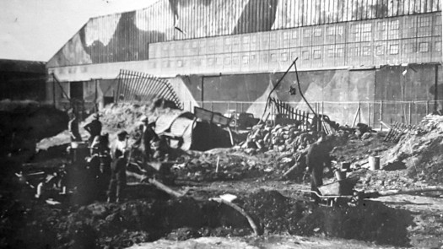
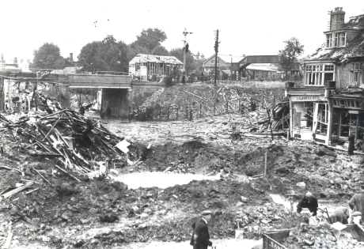
Figure 1. Top: bombed Itchen works, 26th September 1940. Bottom: bombed Woolston works, 26th September 1940.

Following this final raid, Lord Beaverbrook (Minister of Aircraft Production) visited Southampton and ordered abandonment of the Woolston and Itchen works and an immediate start to the complete dispersal of Supermarine production. The dispersal sites became colloquially known as ‘Shadow Factories’, a nod to the secrecy of the whole operation, in order to curtail the risk of enemy bombing. Len Gooch was put in charge, as he was the new Supermarine Works manager. H.B. Pratt had been the previous manager, as already mentioned, but tragically the stress and pressure of his job (teamed with depression) had led him to take his own life (Key, Retrieved 2019) (Viney, 2018).
Gooch and his team moved to the Polygon Hotel in requisitioned rooms, where the dispersal planning commenced. Firstly, they decided to branch out their dispersal sites, to allow for more production and less chance of attack. The areas chosen for the expansion needed to be capable of producing Spitfires from sub-assembly to flight-testing and delivery, but needed to remain within 50 miles of Southampton to allow for efficient control and communication. Starting with Southampton’s centre (as the city was to remain at the heart of it all) the managers drew concentric circles radiating out of the city; the final areas decided on were Newbury, Reading, Salisbury and Trowbridge (Key, Retrieved 2019). Although spreading out production meant that it was harder to ensure that no dispersal locations were leaked to the Germans, this was a risk that Gooch and his team were willing to take.
One of the most important aspects of dispersal was the Design team, as they had with them their invaluable designs and blueprints. Straight after the raids, they had been moved to temporary safe refuge in a group of huts at University College in Highfield, Southampton. However this wasn’t a permanent solution so the MAP requisitioned Hursley Park, an estate near Winchester belonging to the dowager Lady Cooper. It seems that she accepted the requisition without complaint; Hursley Park had been used as a military hospital in World War One, and the Cooper family had been planning on offering it again as a hospital. However, when Lady Cooper’s husband died in early 1940, the government decided that the house would be better used for the Supermarine design office and drawing rooms. Therefore, the entire Design and Production team moved in December 1940, and the move was so successful that they stayed there until 1958 (Hursley Park, 2019). Lady Cooper initially still lived in a wing of the house, until 1942 when she moved to Jermyns House in Hillier Gardens (a well-known local garden and arboretum, which is still visited today) (Hursley Park, 2019). Back at Hursley House, the design department also wanted local, new, young minds, so they selected intelligent 16-year-olds (both girls and boys) from local schools and brought them to Hursley. This helped Supermarine train the best minds, as well as allowing young teenagers to play a part in the war effort.
Lady Cooper is one of the real characters portrayed in the ‘The Shadow Factory’ (Howard Brenton, Nuffield Southampton Theatres, 2018/2019), which is a production dramatising the experiences of Southampton citizens throughout the war (based on real historical accounts.) In the show, she is depicted as being very willing to welcome the design team, even though she realises it may ruin the lavish furnishings. This is because she likes the buzz of having people around; it is a happier environment than having sick people all around her and she wants to help in some way. She even greets the design team upon arrival with a big floral Spitfire, which we know to have been a real event (Figure 2). Clearly, a theatre show cannot be counted as a steadfast source, but it is interesting to observe the popular Southampton opinion of her, which is of a generous elderly woman keen to do her bit. However, it could be argued that she was just choosing to be positive, as after all she did not have a choice, or that she preferred not to be forced to provide a hospital again, which is alluded to in the play. The government legally commandeered property whether one accepted the requisition or not, so perhaps Lady Cooper was just accepting the inevitable.
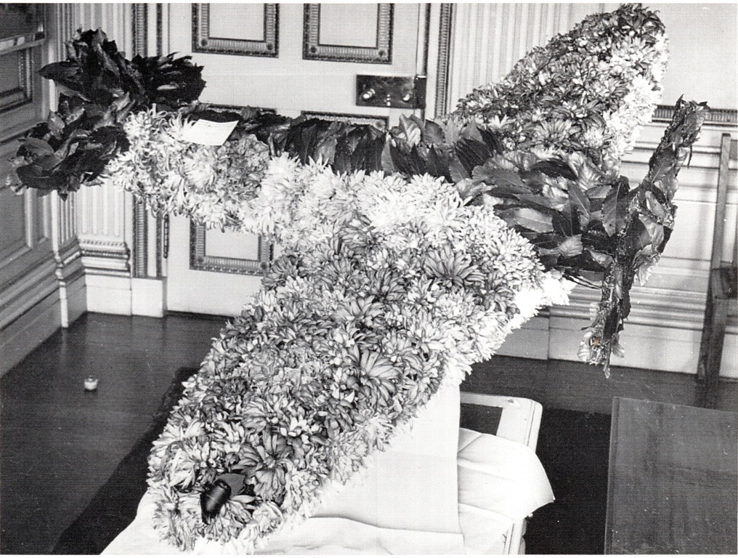

Figure 2. The floral Spitfire presented to the design team by Lady Cooper, December 1940.

The selection process for the other dispersal sites was relatively simple; locations were chosen based on how readily they could be adapted to manufacture certain aircraft components. However, although a simple task, any potential new location still had to be checked by senior staff, meaning they were distracted from their own immense workload. Preferred sites had wide concrete floors, high ceilings and easy access doors. For example, bus depots were particularly valuable, because of the added height that was used to hold buses; this was ideal to make and assemble wings. For this reason, Supermarine sought out both the Salisbury Depot and Hants and Dorset Depot. However, neither was easy to attain; in Salisbury, the Mayor opposed the requisition (due to apprehension that this would lead to Salisbury and its people being bombed), even though he was the local patron of the Spitfire Fund! Lord Beaverbrook reportedly made it blatantly clear to the Mayor that there was no point raising funds to pay for a plane if they couldn’t build them, and promptly pushed his requisitions through regardless (Key, Retrieved 2019).
Acquiring the Hants and Dorset Bus Depot (Figure 3) also created tension, as it had already been requisitioned by Civil Defence to act as a store for sandbags and hoses for the Fire Brigade in the case of another air raid. Supermarine had to ‘negotiate’ with the unwilling Town Clerk to get the Civic Authorities to move their stores and then relied on ‘Beaverbrook’s Boys’ (feared men from the MAP) to ensure that the requisition was successful (Key, Retrieved 2019). Supermarine then embarked on getting the sandbags out and Spitfires in.
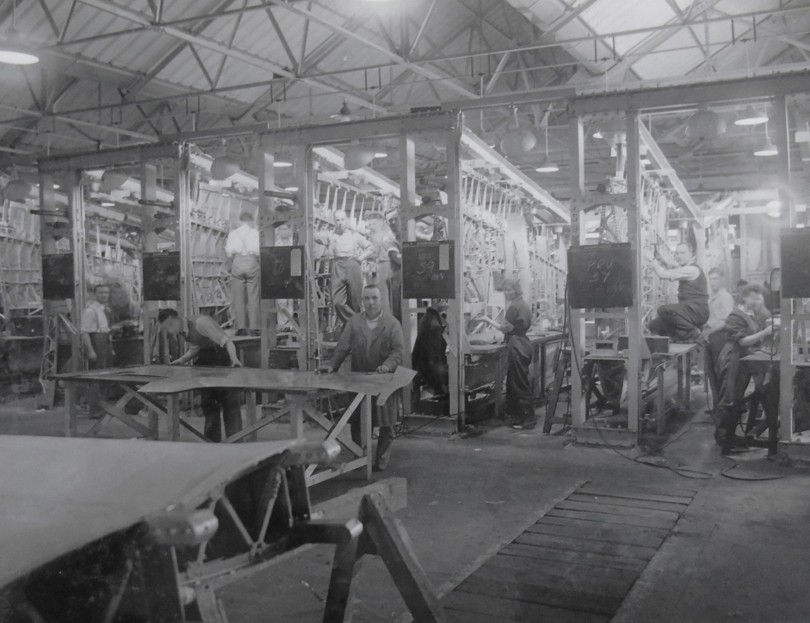

Figure 3. The Hants and Dorset Bus Depot.

Although unpleasant, conflicts between rival Ministries over who requisitioned what - similar to the incident aforementioned - were not uncommon, as the most suitable buildings for Spitfire manufacture were typically also prime locations for other wartime government bodies, such as the Ministry of Supply. Tensions were high, despite the fact that all ministries ultimately aspired to the same goal, namely British victory in the war. Fortunately for Supermarine, at the time aircraft production was of paramount importance for the country. Beaverbrook, and ultimately Churchill, backed the MAP so they nearly always got their way. When the Ministry for Food Supply objected to Supermarine’s power, one MAP man was overheard to yell, ‘You can’t win a war with bloody pineapples!’ (Key, Retrieved 2019). As Beaverbrook and his ‘Beaverbrook’s Boys’ seemed to force their way through everything, the public commonly saw them as bullies and crooks, as shown by Figure 4.

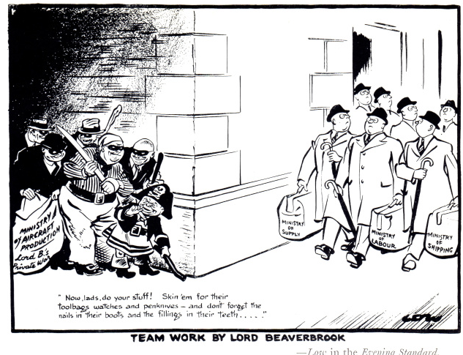

Figure 4. A cartoon from a 1940 Evening Standard newspaper, named ‘Team Work by Lord Beaverbrook.’ The text in the bottom left hand corner (under the thugs representing the MAP) reads, ‘Now, lads, do your stuff! Skin’em for their toolbags watches and penknives – and don’t forget the nails in their boots and the fillings in their teeth…..’

Another group of businesses commonly requisitioned were garages, as they often already had the machinery that could be capable of making complete fuselages. Hendy’s Garage and Seward’s Garage had already previously been taken over by Supermarine, but newly requisitioned garages in Southampton and surrounding areas included Lowther’s Garage (Figure 5), Short’s Garage, Chiswell’s Garage, Garat’s Garage and Vincent’s Garage. As well as general fuselage work, they were also more specifically used for Tool Rooms, Press Shops, Sheet Metal Detail and Transport Repair (Francis, 2018) (Key, Retrieved 2019). This requisitioning actually had a generally positive impact on the garage owners, so they usually acquiesced with no resistance. This was because the wartime restrictions on travel and petrol meant that garages had very little work, so they were actually in need of employment and Supermarine provided just that. It was a win-win situation, as Supermarine could continue their production and garage staff got a guaranteed income.
The Sunlight Laundry (Figure 5) was also requisitioned, and this was a partial success. Fortunately for Gooch, the owners complied well with Supermarine, moving out in a few days with no undue objection. However, the conversion itself took a while, as Supermarine had to remove the cotton lint accumulated in the rafts before they could commence using the building as a fitting shop (Key, Retrieved 2019).
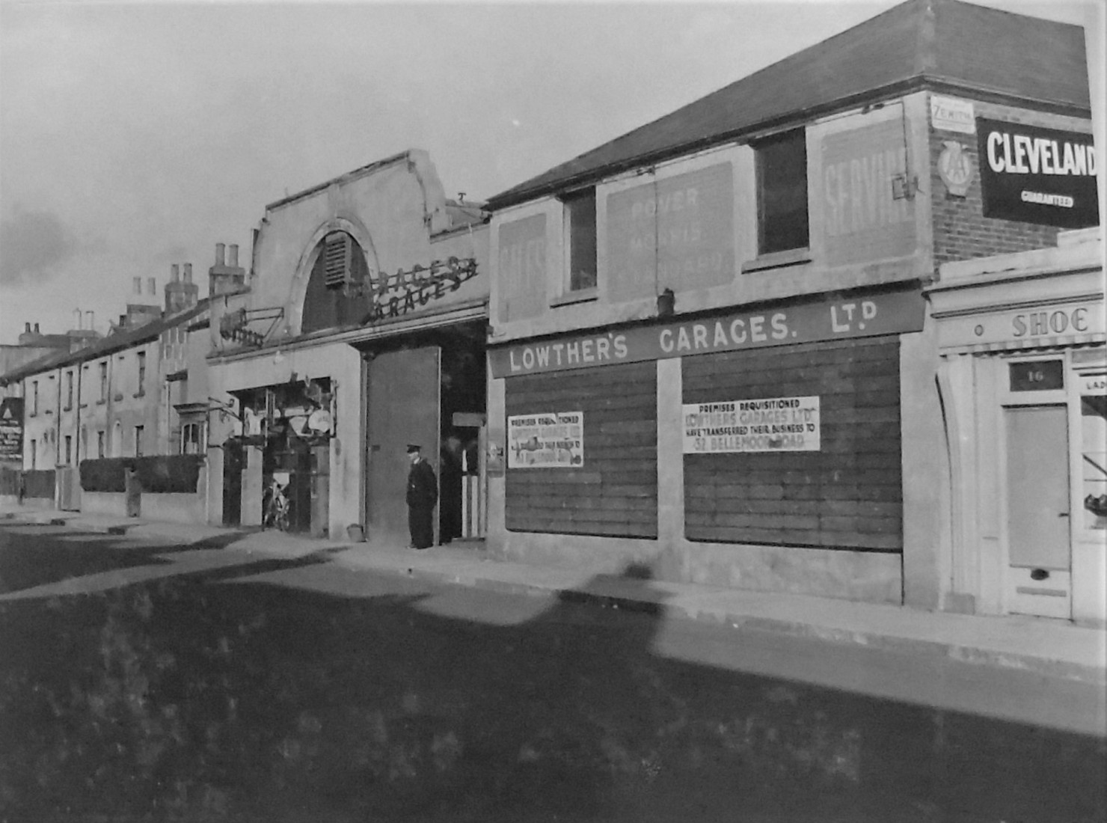
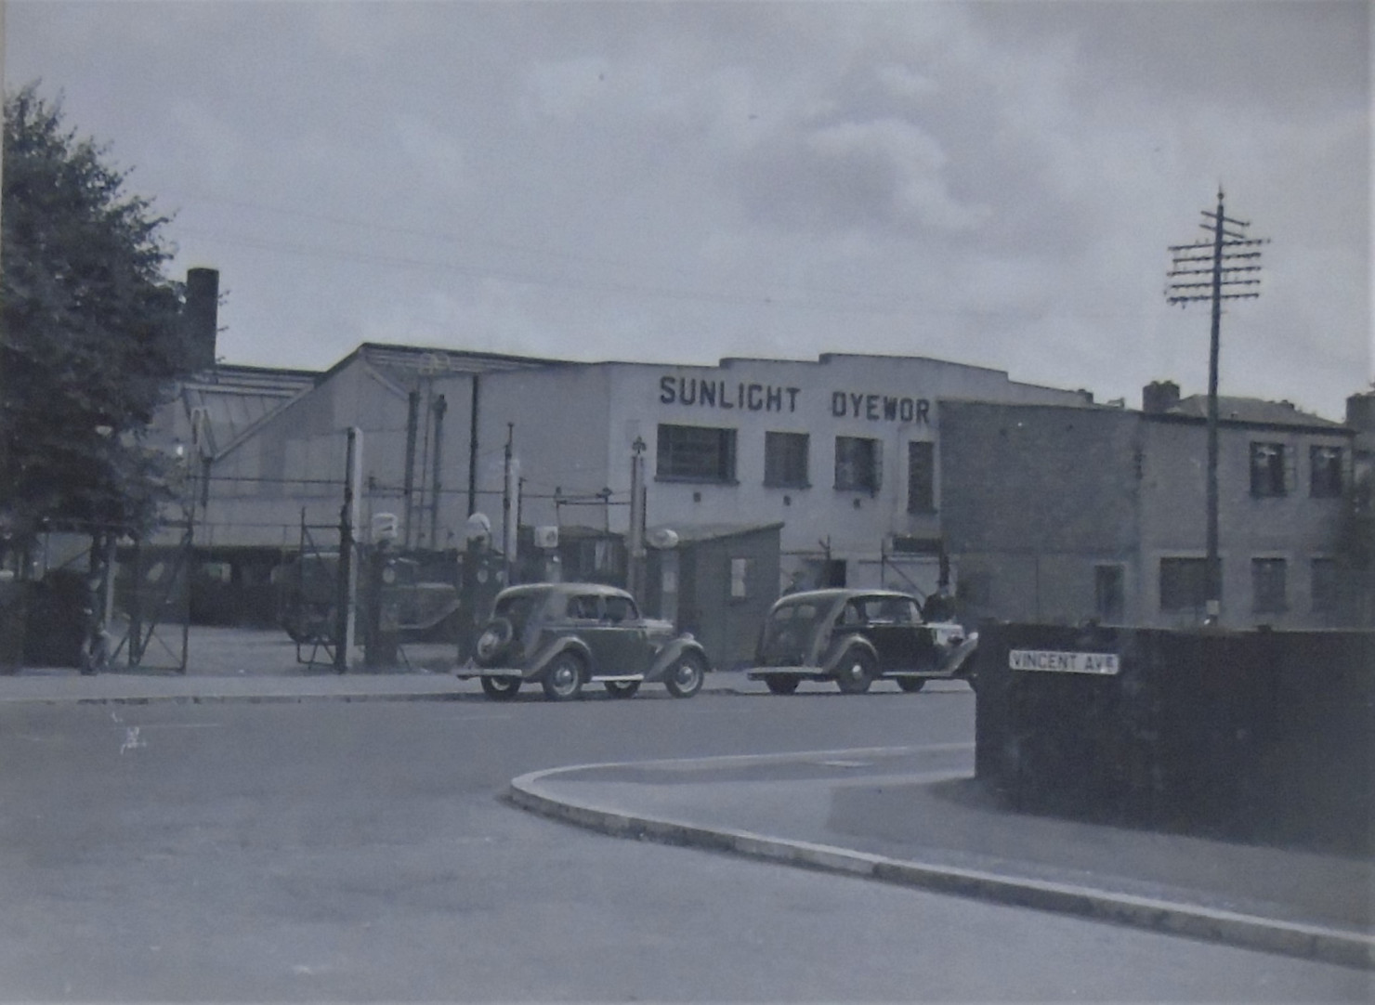
Figure 5. Top: Lowther’s Garage, with MAP requisition notices on the walls. Bottom: Sunlight Laundry.

In stark contrast to the submission of the Sunlight Laundry, the owner of the Barnes Steamroller Factory in Trowbridge (one of the newly set up Spitfire centres) was not at all disposed to give up his premises. Supposedly this was because he believed his steamrollers to be more important than Spitfires, but it is very probable that he was also scared. Many Southampton business owners (and indeed those in Newbury, Reading, Salisbury and Trowbridge) had fears that their sites becoming Spitfire factories would result in the Luftwaffe targeting them, and so they tried to reject the requisition notice. This apprehension was partly based on past evidence, as in June 1940 a stray bomb had hit a store in Bishops Waltham that Supermarine had been using, leading to civilians’ unfounded rumour that their premises would be next (Key, Retrieved 2019). In the case of this particular man, whether he was secretly scared or just didn’t see the importance of Spitfires, he appealed to his local MP. An arbitration panel ruled that the factory would have to be shared (seventy five per cent for Supermarine and twenty five per cent for the steamrollers), so that night the Supermarine workers simply built a wall down the middle and got to work (McKinstry, 2007).
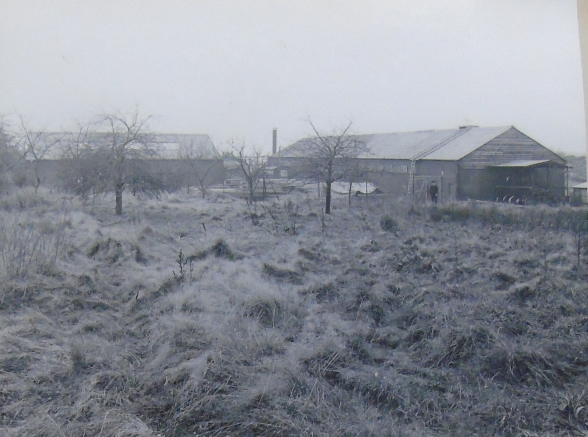
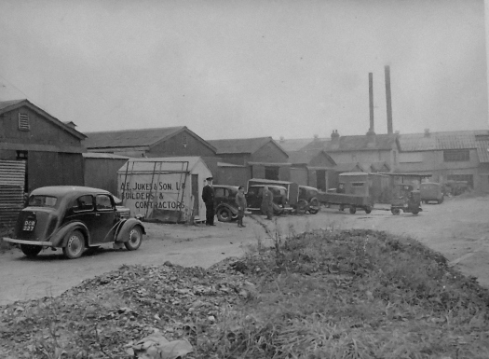
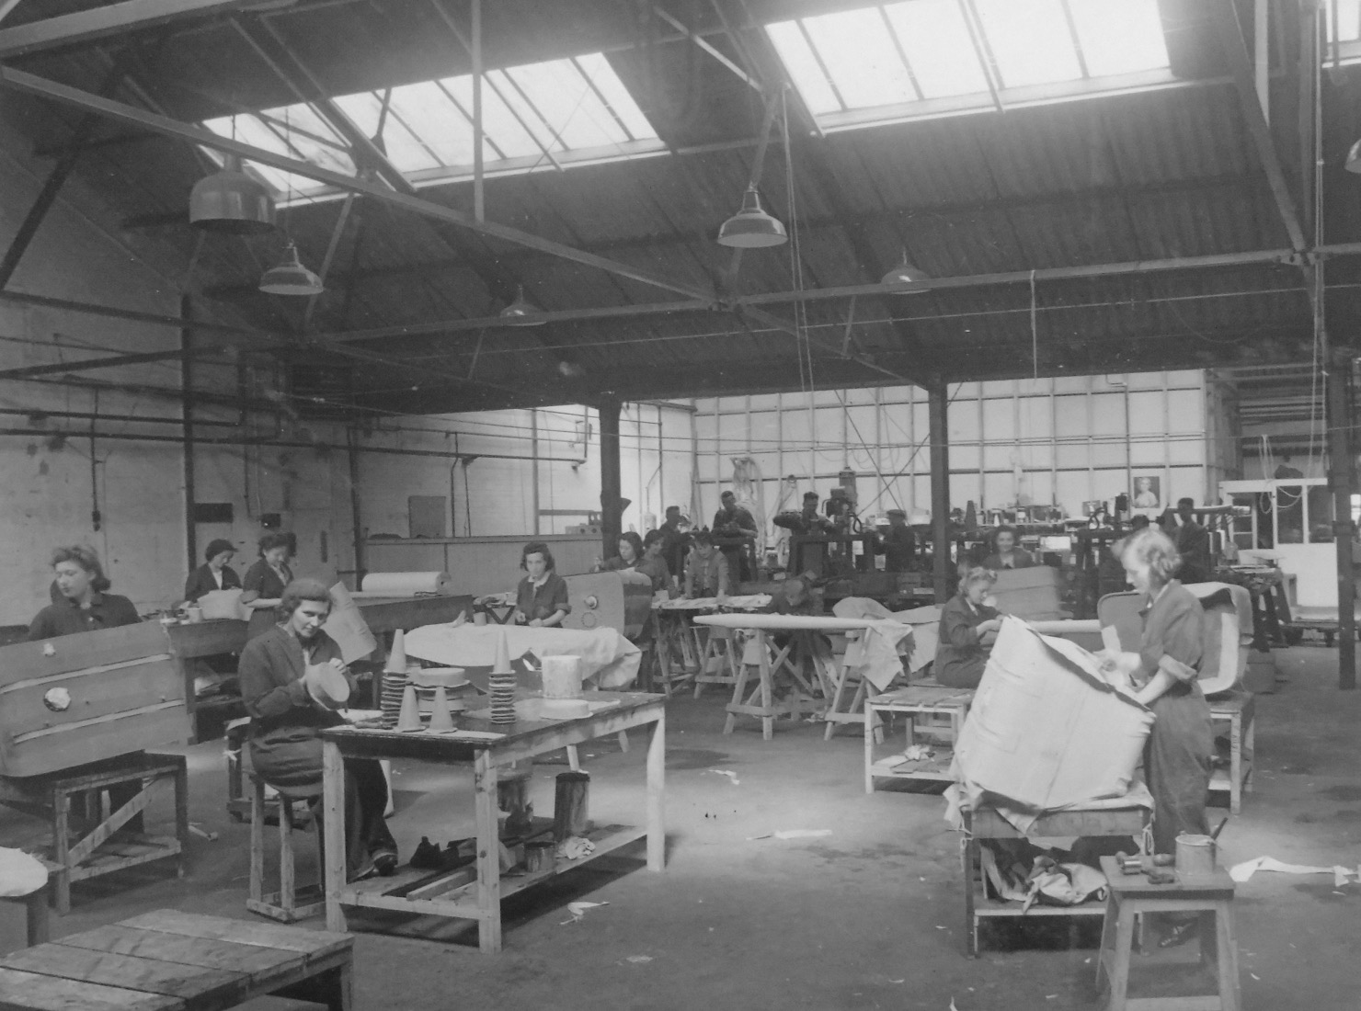
Some other dispersal factories (Figure 6) that have not been mentioned so far included: Weston Works (used as a coppersmiths), Newtown Road (became a wood mill), Austin House (used to make tank coverings), Webbsland Barn (used as a jig store), Eastleigh Stores and Bishop’s Waltham Stores (used as material and general stores), Botley Road Stores, Sholing Stores and Hollybrook Stores (finished parts stores) (Key, Retrieved 2019).
Figure 6. Clockwise from top left: Newtown Road; Austin House; Hollybrook Stores.
Gooch and his team worked very quickly to identify all these sites and more. Despite the variable initial reactions of acceptance, reluctance and opposition, within 6 weeks 35 ‘Shadow Factories’ had been identified and 16 of these were working day and night shifts to get production up and running again. Eventually, there were 60 different workshops in and around Southampton (McKinstry, 2007). This meant that ordinary inhabitants of the city soon found themselves caught up very tangibly in the war effort, seeing their own humble businesses transformed before their eyes, into manufacturers of one of the most important planes in British history.
Even after the dispersal facilities had been established, Gooch’s challenges were still far from over. A main downside to the dispersal was that there was a need for more machinery and jigs, as the equipment that had been cleared from the Woolston works wasn’t enough to supply all the new sites. This was because each ‘Shadow Factory’ was smaller than the original Woolston and Itchen works, but there were more of them and obviously it was not possible to give each site half or a quarter of one machine! The other main negative aspect of the dispersal movement was the distance out of Southampton’s centre that workers would have to travel (especially if the site was in one of the new areas). This meant many of the skilled workers – who had originally been at the Woolston or Itchen works – were reluctant to come back, as they didn’t want to abandon their families to potential bombing in the city. Moreover, there was initially very little accommodation available in these new areas, providing even less incentive for the workers, but fortunately Supermarine soon organised adequate provision.
This was not the only issue with the workforce. In fact, finding a suitable workforce for the dispersal factories seemed to be the most pressing issue faced by Supermarine and the MAP. In order to get production up and running again, all the experienced workers who had previously been with Supermarine were desperately needed, but this was impossible. Some of them of course had either been killed or injured in the raids, and many more had to deal with the aftermath of bombing on their homes and families. Even after Supermarine had managed to persuade some of their previous workers to return, they still needed more, so a new workforce had to be trained very quickly. Some of these were relatively young boys and girls straight out of school, or slightly older men who had gone through the government’s engineering training. There were also many women and retired men, to replace all the men away at war. However, state-of-the-art Spitfire production was a level above anything these people had done previously, so careful training and supervision was required, as well as a lot of time - time the MAP didn’t have to spare. Even with these new workers, Supermarine management found themselves with a considerably smaller total workforce; the 3,660 workers in early September 1940 had dropped to 3,079 by December the same year (McKinstry, 2007). Evidently, the raids truly had a negative impact on Supermarine’s employees.
The ensuing Southampton Blitz of 22nd November – 1st December 1940 was the next difficulty faced by the Spitfire producers. Although miraculously no Supermarine workshop was directly hit, amenities such as gas, electricity and water were unreliable, often forcing production to halt. Moreover, the employees often couldn’t work, for various reasons. Some had to find new places to live (if their homes were among the 45,000 buildings damaged or destroyed), others had to attend to their families, others could not get to work when transport links were down, and of course some workers were among those killed by the blasts. However, the noteworthy ‘Blitz Spirit’ was particularly evident in Southampton, and it must be acknowledged that the workforce in general displayed unstinting, loyal determination to carry on creating Spitfires. They just kept going, for example coming into work the morning after their house had been destroyed, or after a rough night on the Common (Southampton Common became a nightly refuge for ‘trekkers’ – citizens opting to sleep in the park to lessen the risk of dying in a bombed house). German propaganda considered Southampton finished (the fires could reportedly be seen all the way from occupied Cherbourg) but this was far from the truth. The Spitfire workforce simply gritted their teeth and got on with it (McKinstry, 2007) (Key, Retrieved 2019) (Smith, 2017).
Due to all these hardships, Spitfire production fell sharply from 363 aircraft per quarter before the raids to 177 and 179 respectively in the two quarters after the raids. However, manufacturing speed slowly started to recover in mid 1941, until 9 months later it was finally back to the intended 100 per month (300 per quarter) (Walpole, 2004). The recovering dispersal workforce helped with this, as by the end of 1944 the total had rocketed to an incredible 10,000 workers (and half of these were women, many in senior roles.) Considering there had been just 3,079 workers after the raids, this was an incredible achievement for Gooch and his team (McKinstry, 2007).
In conclusion, the dispersal factories of Southampton were planned and executed in the wake of the air raids of September 1940. The impact of these factories was significant on ordinary citizens, from those whose businesses were metamorphosed into secret production sites, to the teenage girls and boys who were trained by Supermarine straight out of school. The dispersal sites were first met with mixed reactions – some reacted with hospitality, others with unease or frank opposition – but however people adapted to the factories, there was without a doubt a significant impact on their everyday lives. Thereafter, any preliminary qualms soon gave way to unshakable dedication and valour, and a satisfaction of contributing to the war effort and serving Britain in such a vital way. Overall, by the end of the war, 8,000 Spitfires had been built in the dispersal factories in and around Southampton and in addition the Spitfire was the only Allied aircraft to be in production throughout the duration of the war. This is a true testament to the character of the Southampton people. The evidence attests to the crucial importance of the Southampton dispersal factories and people; without them and their dispersal factories the world today could be a very different place.

Bibliography
Bishop, P. (2009). Battle of Britain: A day-to-day chronicle, 10 July-31 October 1940. London: Quercus Editions.
Ethell, J. L., & Pace, S. (1997). Spitfire. St. Paul, Minnesota: Motorbooks International.
Francis, P. (2018, March 22). Supermarine dispersal sites in and around Southampton. Retrieved June 20, 2019, from Airfield Research Group: https://www.airfieldresearchgroup.org.uk/forum/general-discussion/14413-supermarine-dispersal-sites-in-and-around-southampton?jjj=1563473694562
Hickman, K. (2018, August 3). World War II: Battle of Britain. Retrieved June 20, 2019, from ThoughtCo.: https://www.thoughtco.com/world-war-ii-battle-of-britain-2360528
Hursley Park, S. (2019, June 20). 1939-1945- World War Two. Retrieved June 20, 2019, from The history of Hursley Park: https://hursleypark.wixsite.com/history/history-overview
Imperial War Museum, S. (2018, January 4). 8 things you need to know about the Battle of Britain. Retrieved June 20, 2019, from Imperial War Museum: https://www.iwm.org.uk/history/8-things-you-need-to-know-about-the-battle-of-britain
Isby, D. (2012). The Decisive Duel: Spitfire vs 109. London: Little, Brown.
Key, D. (2019, June 20). 1939-1940 - The war comes to Southampton. Retrieved June 20, 2019, from The Supermariners: https://supermariners.wordpress.com/the-places/southampton/1939-1940-the-war-comes-to-southampton/
Key, D. (2019, June 20). Southampton Area (Dispersal). Retrieved from The Supermariners: https://supermariners.wordpress.com/the-places/southampton/southampton-area-dispersal/
Key, D. (Retrieved 2019, June 20). The Dispersal (1940 - 1941). Retrieved June 20, 2019, from The Supermariners: https://supermariners.wordpress.com/the-places/southampton/the-dispersal-1940-1941/
McKinstry, L. (2007). Spitfire: Portrait of a Legend. London: John Murray.
Parker, P. (2010). World History. London: Dorling Kindersley.
Smith, R. e. (2017, March 28). National Spitfire Project. Retrieved June 20, 2019, from UK Parliament: https://hansard.parliament.uk/Commons/2017-03-28/debates/6EB2C2FF-A4B2-44C1-B58B-E891E37E18CE/NationalSpitfireProject
Southampton City Council, S. (2019, June 20). The Spitfire connection. Retrieved June 20, 2019, from Southampton City Council: https://www.southampton.gov.uk/arts-heritage/history-southampton/spitfire.aspx
The Spitfire Society, T. (2017, November 30). Luftwaffe raid on Southampton - 26 September 1940. Retrieved June 20, 2019, from The Spitfire Society: http://spitfiresociety.org/blogcontent-13-2-luftwaffe-raid-on-southampton---26-september-1940
Viney, Z. (2018, September 14). Out of the Shadows: A Spitfire story. Retrieved June 20, 2019, from Hampshire Archives and Local Studies: https://hampshirearchivesandlocalstudies.wordpress.com/2018/09/14/out-of-the-shadows-a-spitfire-story/
Walpole, N. (2004). Swift Justice. Barnsley: Pen and Sword Aviation.

Figures:
All reproduced from The Supermariners website: https://supermariners.wordpress.com

Acknowledgement:
Rupert Rowbotham, Head of Engagement, Nuffield Southampton Theatres, for invaluable advice on sources of archive material.

